Liquibase Setup
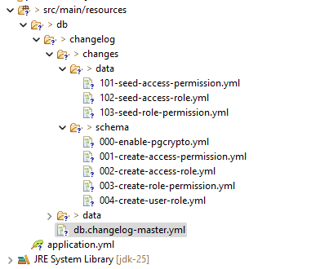
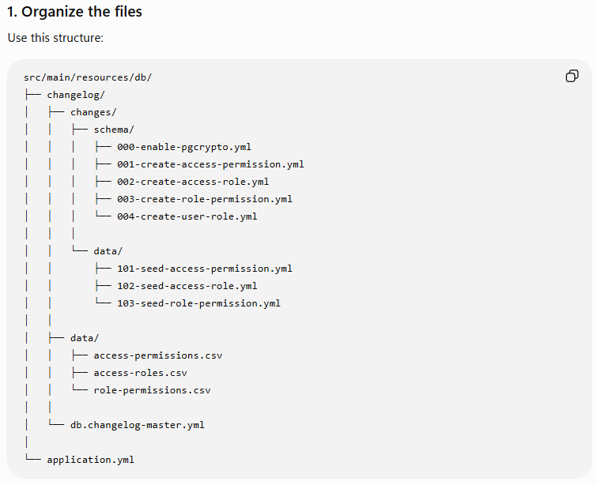
- Setup application.yml
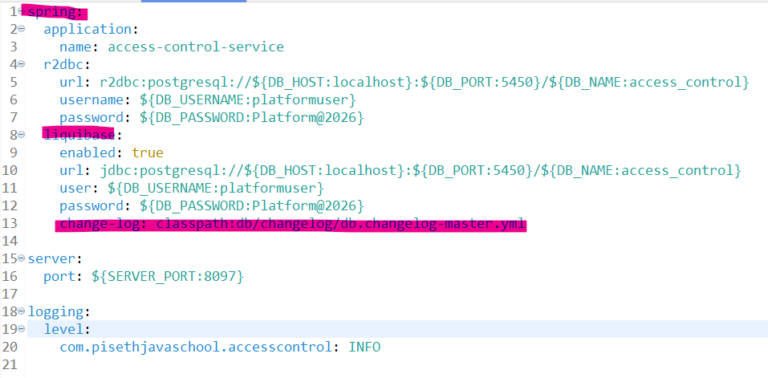

liquibase:
enabled: true
url: jdbc:postgresql://${DB_HOST:localhost}:${DB_PORT:5450}/${DB_NAME:access_control}
user: ${DB_USERNAME:platformuser}
password: ${DB_PASSWORD:Platform@2026}
change-log: classpath:db/changelog/db.changelog-master.yml

- In the db

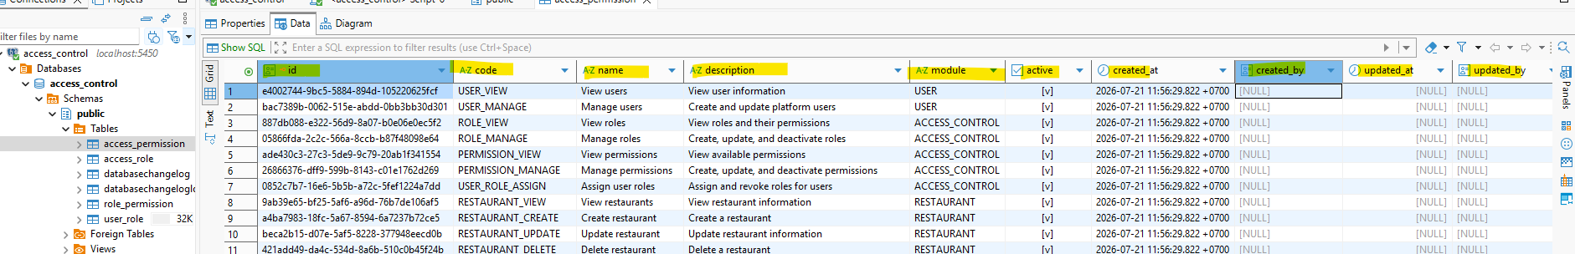

- Sample create table permissions
databaseChangeLog:
- changeSet:
id: 001-create-access-permission
author: ingpiseth
changes:
- createTable:
tableName: access_permission
columns:
- column:
name: id
type: uuid
defaultValueComputed: gen_random_uuid()
constraints:
primaryKey: true
nullable: false
- column:
name: code
type: varchar(100)
constraints:
nullable: false
- column:
name: name
type: varchar(150)
constraints:
nullable: false
- column:
name: description
type: varchar(500)
- column:
name: module
type: varchar(50)
constraints:
nullable: false
- column:
name: active
type: boolean
defaultValueBoolean: true
constraints:
nullable: false
- column:
name: created_at
type: timestamp with time zone
defaultValueComputed: CURRENT_TIMESTAMP
constraints:
nullable: false
- column:
name: created_by
type: uuid
- column:
name: updated_at
type: timestamp with time zone
- column:
name: updated_by
type: uuid
- addUniqueConstraint:
tableName: access_permission
columnNames: code
constraintName: uk_access_permission_code
- createIndex:
tableName: access_permission
indexName: idx_access_permission_module_active
columns:
- column:
name: module
- column:
name: active

- Example insert data
databaseChangeLog:
- changeSet:
id: 001-seed-access-permission
author: ingpiseth
changes:
- loadData:
file: ../../data/access-permissions.csv
relativeToChangelogFile: true
tableName: access_permission
separator: ","
quotchar: '"'

- Db.changlog-master.yml

databaseChangeLog:
# Database extensions
- include:
file: changes/schema/000-enable-pgcrypto.yml
relativeToChangelogFile: true

# Schema
- include:
file: changes/schema/001-create-access-permission.yml
relativeToChangelogFile: true

- include:
file: changes/schema/002-create-access-role.yml
relativeToChangelogFile: true

- include:
file: changes/schema/003-create-role-permission.yml
relativeToChangelogFile: true

- include:
file: changes/schema/004-create-user-role.yml
relativeToChangelogFile: true

# Seed data
- include:
file: changes/data/101-seed-access-permission.yml
relativeToChangelogFile: true

- include:
file: changes/data/102-seed-access-role.yml
relativeToChangelogFile: true

- include:
file: changes/data/103-seed-role-permission.yml
relativeToChangelogFile: true

